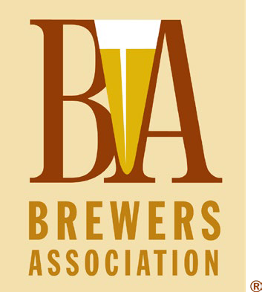

[BrewersAssociation.org](https://www.brewersassociation.org/)

**EXAMPLE**

Standard Operation Procedure:

**Remote Hop Selection**

Objective

*This document is an example of a standard operating procedure (SOP) for remote hop selection of a hazy IPA brand. The values listed in this example SOP are hypothetical. Breweries are encouraged to use this example as a template to build their internal SOP for their facility’s remote hop selection process.*

Consistently select hop lots with high aroma intensity, juicy/tropical fruit character, and low levels of undesirable notes (onion, garlic, grass) for use in hazy IPA dry-hopping and late additions, without being physically present at the hop supplier.

**1. Timing & Planning**

* Contact suppliers early (pre-harvest) to:
  + Secure varietals and volumes
  + Communicate desired aroma profile
* Provide prior year’s lot numbers and descriptive feedback to align on target profiles.

**2. Sample Request Protocol**

Request the following from each supplier:

* 3–5 lots per hop variety
* 100–200g of whole-cone samples (vacuum-sealed or nitrogen-flushed)
* Certificate of Analysis (COA) for each lot, including:
  + Alpha acids, beta acids
  + Total oil content and breakdown (especially myrcene, humulene, linalool, geraniol)
  + Hop Storage Index (HSI)
  + Moisture %

*Optional:*

* Sensory oil vials or distillates (if available)
* Hop rub/grind video walkthroughs or live Zoom sessions with supplier

**3. Sensory Evaluation Procedure**

**Environment:**

* Clean, neutral room (no strong odors, food, coffee, etc.)
* Sensory panel of 2–4 trained staff (if possible)
* Use gloves and blank scoring sheets

**Steps:**

1. Blind code samples. Label samples as Lot A, B, C, etc. or assign a random numerical code.
2. Perform hop grind or rub and sniff method but be consistent. For a rub evaluation use 2–3 cones per sample.
3. Evaluate based on:
   * Aroma intensity (1–5)
   * Key descriptors (tropical fruit, stone fruit, citrus, diesel, herbal, etc.)
   * Negative indicators (cheese, garlic/onion, lawn clippings)
4. Record impressions for each sample.

**EXAMPLE Selection Criteria for Hazy IPAs:**

| **Preferred** | **Avoid** |
| --- | --- |
| Mango, passionfruit, pineapple, orange, guava, peach | Onion/garlic, musty, grassy, catty |
| Smooth, soft, rounded aromas | Harsh green or vegetal bite |
| High linalool, geraniol | High HSI (>0.3–0.4), oxidation |
| Clean bitterness potential | Astringency or sharp phenols |

**4. EXAMPLE Technical Evaluation**

Compare COA data with sensory impressions:

* Look for total oil ≥ 2.0 mL/100g for high-impact aroma.
* Prioritize higher linalool, geraniol, and low humulene:caryophyllene ratio (helps with hazy fruit-forward expression).
* Disqualify lots with high HSI, excessive moisture, or poor oil content.

**5. Final Decision Process**

1. Consolidate panel scores + COA evaluation in a spreadsheet or selection sheet.
2. Rank lots based on:
   * Alignment with flavor goals
   * Consistency with house flavor profile
   * Compatibility with your yeast strain
3. Inform supplier of selected/ranked lots with clear documentation.

**6. Documentation and Follow-up**

* Store notes and COAs with year and variety for future reference.
* Provide feedback to suppliers on selected and rejected lots.
* Update your hop selection profile to guide future years.

**EXAMPLE SOP Summary Table**

| **Step** | **Task** | **Responsible** | **Tool** |
| --- | --- | --- | --- |
| 1 | Pre-harvest planning | Head Brewer | Email, Excel |
| 2 | Request samples & COAs | Buyer or Head Brewer | Email, Order Form |
| 3 | Analyze COAs | Head Brewer | COA spreadsheet |
| 4 | Rank & select | Sensory Panel | Hop selection sheet |
| 5 | Archive & feedback | Brewer | Google Drive or Brewery DB |

*Courtesy of James “Otto” Ottolini of Schlafly.*